SUPERSTORE DASHBOARD ANALYSIS/REPORT

Overview
This analysis evaluates sales and profitability performance across product categories, sub-categories, time, and regions. While overall sales show steady growth, profitability remains inconsistent, indicating underlying inefficiencies in pricing, product mix, and regional performance.

Key Findings
- Underperforming Categories & Sub-Categories
Several sub-categories are contributing minimally or negatively to profit, notably:
- Tables
- Bookcases
- Supplies
- Fasteners
These segments exhibit weak profit margins despite ongoing sales activity. In contrast, sub-categories such as Copiers and Phones drive a significant share of total profit.
Implication: Profitability is concentrated in a narrow set of products, exposing the business to imbalance and inefficiency.

Sales vs Profit Trends
Sales demonstrate a consistent upward trend over time. Profit, however, fluctuates and does not proportionally increase with sales.
Implication: Revenue growth is being achieved at the expense of margins, indicating operational or pricing inefficiencies.

Drivers of Declining Profitability
- High Discounting: A clear inverse relationship exists between discount levels and profit. Higher discounts frequently result in reduced or negative profit.
- Sales–Profit Disconnect: Certain segments generate strong sales but low returns, suggesting low-margin products or ineffective pricing strategies.
- Product Mix Imbalance: Continued reliance on underperforming sub-categories reduces overall efficiency and profitability.
Implication: Current strategies prioritize volume over value, weakening financial performance.

- Regional Performance & Major Decline
Region | Performance Summary
West | Highest sales and profit; strongest overall performance
East | Stable and consistently profitable
Central | Moderate performance with controlled outcomes
South | Lowest profit despite moderate sales; weakest performer
Major Decline Identified: South Region
The South region records the lowest profitability while maintaining moderate sales levels, indicating poor efficiency. This suggests excessive discounting, weak product mix, or cost-related challenges.

Conclusion
Although the business is achieving sales growth, profitability is undermined by heavy discounting, underperforming product segments, and regional inefficiencies—particularly in the South. Without strategic adjustments, continued revenue growth may not translate into improved financial performance.

Recommendations

Optimize discount strategies to protect margins
- Reassess or phase out low-performing sub-categories
- Focus on high-margin products to drive profitability
- Implement region-specific pricing and sales strategies
- Improve product mix to enhance overall efficiency

Visuals of my PowerBi Dashboard
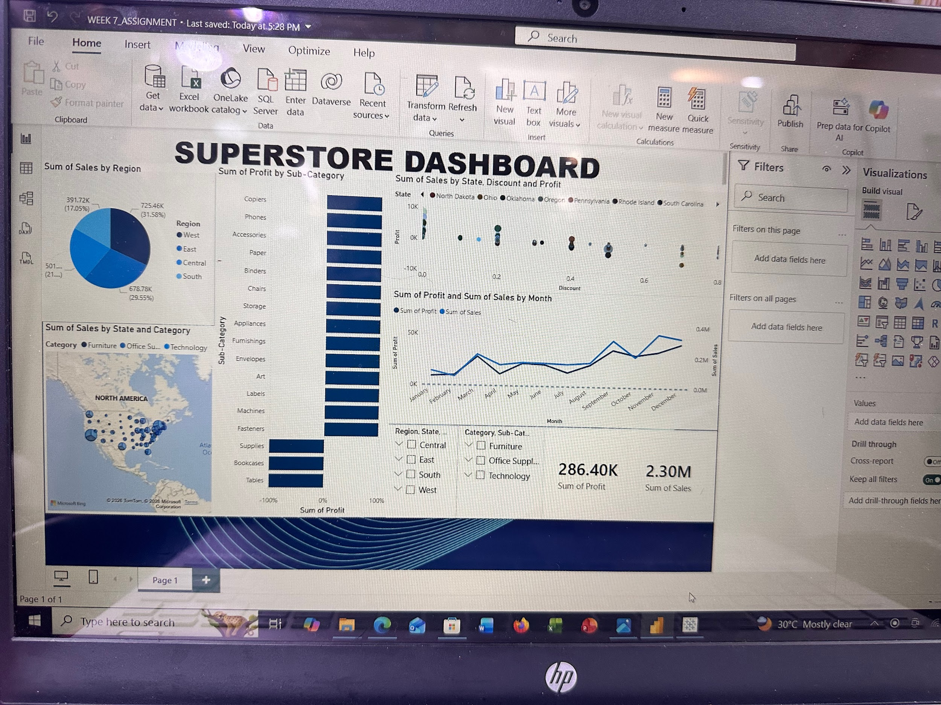

Visuals of my Tableau Dashboard
